Query 1:

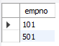

Query 2:



Query 3:

